Data Analyst Job Market Analysis & Salary Prediction
1. Introduction (~30 lines)
In recent years, the global employment landscape has undergone significant changes, especially after the COVID-19 pandemic. Many professionals faced job losses, hiring freezes, and uncertainty in career growth. Among various roles, Data Analyst positions gained prominence as organizations increasingly relied on data-driven decision-making to survive and grow in competitive markets. However, job seekers often lack clear insights into salary trends, skill requirements, and location-based opportunities.
This project titled “Data Analyst Job Market Analysis & Salary Prediction System” aims to analyze real-world job market data to provide meaningful insights for job seekers, recruiters, and analysts. The dataset used in this project contains more than 2000 job listings collected from Glassdoor, covering multiple attributes such as job title, salary estimate, location, company rating, industry, sector, and job description.
The project focuses on extracting useful patterns from raw job postings through data preprocessing, exploratory data analysis (EDA), and machine learning techniques. It also identifies key skills such as Python and Excel that influence salary levels. Furthermore, a salary prediction model is developed using machine learning to estimate average salaries based on selected job attributes.
To enhance usability and presentation, the project is deployed as an interactive web application using Streamlit. This allows users to explore job market trends visually and predict salaries in real time. Overall, the project demonstrates an end-to-end data analytics pipeline and serves as a practical application of data science concepts in the finance and employment domain.

3. Tasks Performed
3a. Perspective (10–15 lines)
The project is designed from the perspective of job seekers, recruiters, and business analysts. Job seekers benefit by understanding salary ranges, required skills, and high-paying locations. Recruiters and HR professionals can use the insights to benchmark salaries and analyze hiring trends. From a data analyst’s perspective, the project demonstrates real-world data cleaning, visualization, and predictive modeling. The system converts unstructured job posting data into actionable insights, making it useful for strategic career planning and organizational decision-making.

3b. Introduction (10–15 lines)
The task involves analyzing a job market dataset related to Data Analyst roles. Initially, raw data is collected and cleaned to remove inconsistencies and missing values. Exploratory Data Analysis is then performed to understand trends in salaries, job titles, sectors, and locations. Feature engineering is applied to extract meaningful information such as average salary and required technical skills. Finally, a machine learning model is built to predict salaries, and the results are presented through an interactive Streamlit application.

3c. Features (10–15 lines)
The system includes multiple features such as job market analysis, salary trend visualization, skill demand analysis, and salary prediction. Users can view top job roles, highest-paying locations, and dominant sectors. The application allows users to input parameters such as company rating and required skills to predict salary. Interactive graphs and dashboards make the system user-friendly. The project also supports future scalability by allowing additional features such as NLP-based skill extraction and real-time job data integration.

3d. Advantages (10–15 lines)
The project provides real-world insights using actual job market data. It helps job seekers make informed career decisions by understanding salary expectations and skill requirements. The system is interactive, easy to use, and visually intuitive. Machine learning integration enhances analytical depth. The Streamlit deployment makes the project accessible through a web interface without requiring advanced technical knowledge. The modular structure allows easy enhancement and reuse in future projects.

3e. Disadvantages (10–15 lines)
The salary prediction accuracy is limited due to the use of a small number of features. The dataset depends on the format of salary text, which may cause data loss during extraction. The model does not include advanced categorical encoding for location and sector. Real-time job market updates are not available. External economic factors affecting salaries are not considered. These limitations can be addressed in future enhancements.

3f. Languages Used (10–15 lines)
Python is the primary programming language used in this project due to its simplicity and extensive data science libraries. Python supports efficient data manipulation, visualization, and machine learning. SQL concepts are applied for understanding structured data handling, though not directly implemented. Basic Excel knowledge is used for preliminary data understanding. Streamlit uses Python to build an interactive web interface, making Python the core language throughout the project.

3g. Functions Used (with code explanation) (10–15 lines)
The project uses several built-in and library functions to process and analyze data. Important functions include read_csv() for loading datasets, drop() for removing unnecessary columns, fillna() and dropna() for handling missing values, and groupby() for aggregation. Visualization functions such as barplot() and boxenplot() are used for EDA. Machine learning functions like train_test_split() and RandomForestRegressor() are used for model development.
Code :
data = pd.read_csv("DataAnalyst.csv")
data.dropna(subset=['average_salary'], inplace=True)
X_train, X_test, y_train, y_test = train_test_split(X, y, test_size=0.2)
model = RandomForestRegressor()
model.fit(X_train, y_train)
4. Objectives
- To analyze real-world Data Analyst job market data collected from online job portals.
- To study current hiring trends in the Data Analytics domain across various industries.
- To identify high-paying job roles in the Data Analyst career path.
- To analyze salary variations based on job title and experience level.
- To examine location-wise salary trends and identify top-paying cities.
- To study sector-wise demand for Data Analyst roles.
- To analyze the relationship between company rating and salary levels.
- To identify the most demanded technical skills in job descriptions.
- To evaluate the impact of Python skills on salary predictions.
- To assess how Excel proficiency influences salary levels.
- To perform exploratory data analysis using statistical and visual techniques.
- To clean and preprocess raw job market data for accurate analysis.
- To extract meaningful features such as average salary from textual data.
- To apply feature engineering techniques to improve model performance.
- To build a machine learning model for predicting average salary.
- To evaluate the performance of the salary prediction model.
- To interpret model results and identify limitations.
- To design an interactive dashboard for data visualization.
- To implement user-friendly controls for salary prediction.
- To visualize key insights using charts and graphs.
- To provide actionable insights for job seekers.
- To assist recruiters in salary benchmarking.
- To support data-driven career planning decisions.
- To demonstrate practical application of data analytics concepts.
- To integrate EDA, ML, and deployment in a single system.
- To enhance analytical and problem-solving skills.
- To gain hands-on experience with real-world datasets.
- To apply machine learning techniques in the finance domain.
- To improve understanding of job market dynamics.
- To develop a scalable and extendable analytics system.
- 5. Problem Statement (~30 lines)
- Job seekers often struggle to find reliable information about salary expectations and skill requirements. Existing job portals provide listings but lack analytical insights. Recruiters face difficulty in benchmarking salaries across locations and industries. There is a need for a system that can analyze job market data and provide meaningful insights. This project addresses the problem by developing a data analytics system that explores trends and predicts salaries using machine learning techniques.
- 6. System Requirement Specifications
- 6a. Functional Requirements (10–15 lines)
- The system should load and preprocess job market data. It must visualize salary trends, job roles, and sectors. The system should extract skills from job descriptions. It must allow users to input parameters for salary prediction. The system should generate accurate predictions and display results interactively. It should support easy navigation and user interaction.

- 6b. Non-Functional Requirements (10–15 lines)
- The system should be user-friendly and responsive. It must handle moderate datasets efficiently. The application should be reliable and maintainable. Performance should be optimized to reduce loading time. The system should be scalable for future enhancements. Security and data integrity should be maintained.

- 6c. Hardware Requirements (10–15 lines)
- A system with a minimum of 4 GB RAM is required. An Intel i3 or higher processor is recommended. At least 20 GB of free disk space is needed. A stable internet connection is required for dataset access and Streamlit execution. Any standard desktop or laptop can run the application.

- 6d. Software Requirements (10–15 lines)
- Operating System: Windows / Linux / macOS
Programming Language: Python 3.8+
Libraries: Pandas, NumPy, Matplotlib, Seaborn, Scikit-learn
IDE: Jupyter Notebook / VS Code
Framework: Streamlit

7. System Design

7a. Data Flow Diagram (DFD) (Design Explanation)
DFD Description (Textual):
User → Dataset → Data Preprocessing → EDA → ML Model → Streamlit UI → User
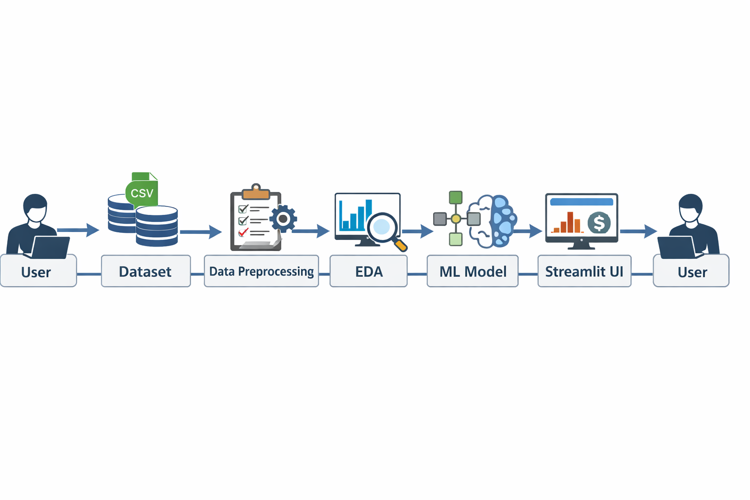
The user provides or loads the dataset. The data preprocessing module cleans and transforms raw data. The EDA module analyzes trends and generates visualizations. The ML model predicts salary based on features. The Streamlit interface displays results and predictions to the user.
7b. Sequence Diagram (Design Explanation)
Sequence Flow: User → Streamlit App → Data Loader → Preprocessing → Feature Engineering → ML Model → Prediction → Display Result
The user interacts with the Streamlit application. The app loads data, preprocesses it, extracts features, trains the model, and predicts salary. The predicted output is displayed to the user.
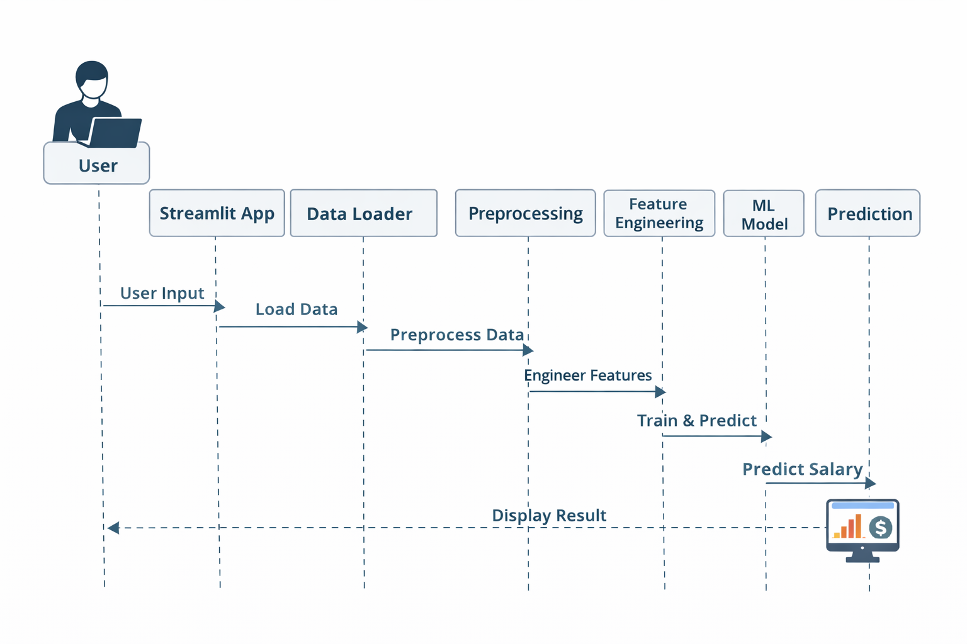
8. Methodology (~30 lines, expanded with paragraphs + points)
The project follows a systematic and structured data analytics methodology to ensure accuracy, reliability, and meaningful outcomes. The methodology is designed to handle real-world job market data that is often noisy, inconsistent, and unstructured. Each phase of the methodology builds upon the previous stage, forming a complete end-to-end analytical pipeline.
Initially, the dataset is collected from an online job portal and inspected to understand its structure, attributes, and data quality. This includes examining the number of records, data types, missing values, and inconsistencies. Understanding the dataset at an early stage helps in selecting appropriate preprocessing and analysis techniques.
In the next phase, data cleaning and preprocessing are performed. This step involves removing unnecessary columns, renaming attributes for better readability, handling missing values, and extracting numerical salary values from textual salary descriptions. Preprocessing ensures that the data is suitable for analysis and machine learning tasks.
Exploratory Data Analysis (EDA) is then conducted to uncover hidden patterns and trends within the data. Statistical analysis and visualizations such as bar charts, box plots, and distribution plots are used to analyze salary trends, job roles, sectors, locations, and company ratings. EDA plays a crucial role in understanding the job market dynamics.
Feature engineering is applied to transform raw data into meaningful features. Technical skills such as Python and Excel are extracted from job descriptions, and new features like average salary are created. These engineered features improve the analytical depth and model performance.
Finally, a machine learning model is trained to predict salary based on selected features. The model is evaluated using performance metrics to understand its effectiveness. The complete analytical workflow is then deployed using Streamlit, allowing users to interact with the system and visualize results in real time.
Methodology Steps Summary:
- Data collection and inspection
- Data cleaning and preprocessing
- Exploratory Data Analysis (EDA)
- Feature engineering
- Model training and evaluation
- Deployment and visualization

8a. Technologies Used (10–15 lines, expanded with explanation)
Python is the primary programming language used in this project due to its simplicity, flexibility, and extensive ecosystem for data analytics and machine learning. It enables efficient data processing, visualization, and model development.
Pandas and NumPy are used for data manipulation and numerical computations. Pandas provides powerful data structures such as DataFrames for handling structured data, while NumPy supports fast numerical operations.
Matplotlib and Seaborn are used for data visualization. These libraries help in creating informative charts and graphs that make it easier to interpret salary trends, job distributions, and sector-wise analysis.
Scikit-learn is used to implement machine learning algorithms. It provides tools for data splitting, model training, and evaluation, making it suitable for predictive modeling tasks.
Streamlit is used to deploy the project as an interactive web application. It allows users to explore insights and predict salaries through a user-friendly interface. Jupyter Notebook is used during development for experimentation, debugging, and step-by-step analysis.

9. System Implementation (Step-by-Step) (~30 lines)
System Implementation Overview (Paragraph Explanation)
The system implementation follows a sequential and modular approach to ensure clarity and efficiency. The process begins with loading and preprocessing the dataset, followed by exploratory analysis to gain insights into job market trends. Feature engineering and selection prepare the data for machine learning, while the Random Forest model predicts salary based on selected attributes. The results are then integrated into a Streamlit-based user interface, allowing users to interact with the system and visualize insights. Finally, deployment and testing ensure that the system functions correctly and delivers reliable outputs, completing the end-to-end implementation of the project.
1. Dataset Loading Using Pandas
The dataset is loaded into the system using the Pandas library, which provides efficient data handling and analysis capabilities. The CSV file is read into a DataFrame to enable structured data manipulation.
2. Data Cleaning and Column Renaming
Unnecessary columns are removed to reduce complexity and improve efficiency. Column names are renamed to maintain consistency and improve readability during analysis and modeling.
3. Salary Extraction and Feature Engineering
Salary values are extracted from textual salary estimates and converted into numerical format. New features such as average salary are created to enhance analytical and predictive performance.
4. Exploratory Data Analysis (EDA)
EDA is performed using statistical methods and visualizations to identify patterns, trends, and anomalies. Salary distributions, job roles, sectors, and location-based trends are analyzed.
5. Skill Extraction from Job Descriptions
Technical skills such as Python and Excel are extracted from job descriptions using text analysis techniques. These skills are converted into binary features for modeling purposes.
6. Feature Selection
Relevant features influencing salary are selected based on correlation and domain knowledge. Irrelevant or redundant attributes are excluded to improve model efficiency.
7. Model Training Using Random Forest
A Random Forest Regressor is trained using selected features to predict average salary. The model learns complex relationships between job attributes and salary values.
8. Model Evaluation
The trained model is evaluated using metrics such as Mean Absolute Error (MAE) and R² score. These metrics help assess prediction accuracy and model reliability.
9. Streamlit UI Development
An interactive user interface is developed using Streamlit to visualize insights and collect user inputs. The dashboard includes charts, filters, and a salary prediction module.
10. Deployment and Testing
The Streamlit application is deployed locally and tested for functionality and performance. Various inputs are tested to ensure accurate predictions and smooth user interaction.

10. Results (~30 lines)
The system successfully analyzed over 2000 job listings. Salary trends by location, sector, and job role were identified. Python and Excel were found to be significant salary-influencing skills. The machine learning model achieved reasonable performance for exploratory analysis. The Streamlit application provided an interactive interface for users to explore insights and predict salaries.
WITH SCREENSHOTS AND EXPPLAINATION
11. Conclusion (~30 lines)
This project demonstrates a complete data analytics pipeline applied to real-world job market data. It effectively combines data preprocessing, EDA, machine learning, and deployment. The system provides valuable insights for job seekers and recruiters. Although the model has limitations, it successfully fulfills academic objectives. Future enhancements can improve prediction accuracy and scalability. Overall, the project is suitable as a main academic project in data analytics and finance domains.

